MST Lesson Plan
Overview—Minimal Spanning Trees
Summary
Many networks link our society: telephone networks, utility supply networks, computer networks, and road networks. For a particular network there is usually some choice about where the roads, cables, or radio links can be placed. We need to find ways of efficiently linking objects in a network.
What | Time | Where
Muddy City | 10 min | MSTLessonPlan.docx  MSTWorksheets.pptx
Discussion | 5 min | MSTLessonPlan.docx
Halloween Candy | 10 min | MSTWorksheets.pptx
Wrap Up | 10 min | MSTLessonPlan.docx
DIY MST | 15 min | MSTLessonPlan.docx

Materials
Each child will need:
- The Muddy City Problem
- The Halloween Decorations Problem
- 50 Q-tips, 10 pennies

Materials adapted by the Colorado School of Mines with permission from Computer Science Unplugged (http://csunplugged.org)

Cheat Sheet
Terminology-
Graph- A network of nodes
Cost- The amount of resources it takes to connect two nodes together.
Minimal Spanning Tree – A graph where every node is connected to the graph for the overall cheapest cost.

Activity 1 - Muddy City Worksheet
Introduction
This activity will show how computers are used to find the best solutions for real-life problems such as how to link power lines between houses. Pass out the worksheets and explain the following story:
Once upon a time there was a city that had no roads. Getting around the city was particularly difficult after rainstorms because the ground became very muddy—cars got stuck in the mud and people got their boots dirty. The mayor of the city decided that some of the streets must be paved, but didn’t want to spend more money than necessary because the city also wanted to build a swimming pool. The mayor therefore specified two conditions:
- Enough streets must be paved so that it is possible for everyone to travel from their house to anyone else’s house only along paved roads, and
- The paving should cost as little as possible. The cost to pave one block is $1.

The number of paving stones between each house represents the cost of paving that route. Find the best route that connects all the houses, but uses as few counters (paving stones) as possible.

Muddy City Discussion- Whole Class
Lesson Vocabulary (you may want to write on board)
- graph
- abstraction
- algorithm
- minimal spanning tree (optional)
- Kruskal (optional)

Discuss the solutions the children have found. What strategies did they use?
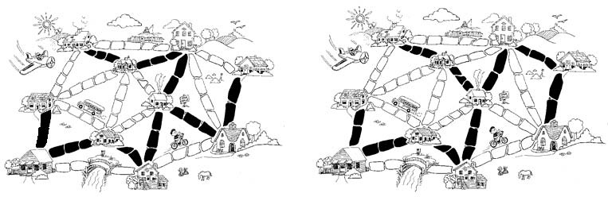
One good strategy to find the best solution is to start with an empty map, and gradually add counters until all of the houses are linked, adding the paths in increasing order of length, but not linking houses that are already linked. Different solutions are found if you change the order in which paths of the same length are added. Two possible solutions are shown in figure 1.
Figure 1: Muddy City Solutions

Another strategy is to start with all of the paths paved, and then remove paths you don’t need. This takes much more effort, however.
Where would you find networks in real life?

A solution using graphs.

Here is another way of representing the cities and roads. In figure 2, the houses are represented by circles, the muddy roads by lines, and the length of a road is given by the number beside the line.
$
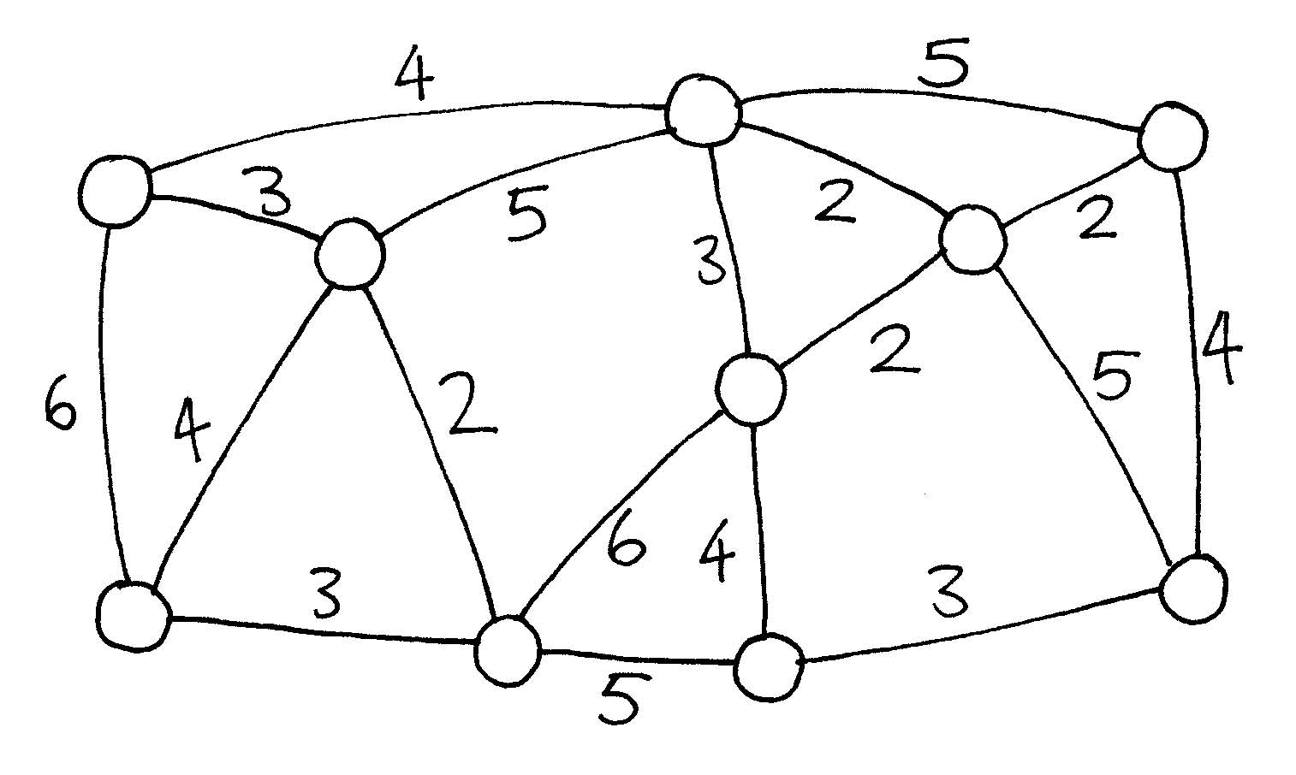
$
$
$
$
$
$
$
$
$
$
$
$
$
$
$
$
$
Figure 2: Graph of Muddy City problem

Computer scientists and mathematicians often use this sort of diagram to represent these problems. They call it a graph. This may be confusing at first because “graph” is sometimes used in statistics to mean a chart displaying numerical data, such as a bar graph, but the graphs that computer scientists use are not related to these. The lengths do not have to be drawn to scale.
The advantage of using this representation is that it focuses on just the important details. Computer scientists call this abstraction.

Using Kruskal’s algorithm (step-by-step process), a minimal spanning tree can be constructed by starting with the lowest cost edge, then continually adding the next lowest cost edge (line) until all vertices (circles) have been reached.

Using the graph shown in figure 2, first shade all of the graph edges with a cost of 2 (you may want to shade entire line). The result is shown in figure 3.
Figure 3: First step of Kruskal's algorithm

Next shade in edges of cost 3, unless the two circles (houses) have already been attached to the network. As shown in figure 4, this adds three more edges. The path of cost 3 with the red line through it is not needed, because the two circles (houses) can already be reached via paths with a lower cost.

NOTE: it may seem confusing that we aren’t starting in one place and continuing to draw connected path. Since we already know the entire graph, we can make more holistic/effective decisions.
Figure 4: Step 2 of Kruskal's algorithm

At this point each house has at least one paved path leading to it. But are they all connected? Let’s ensure we can get to every house.
- Pick a house at random to start and fill it in (shown in figure 5 as a blue circle with x).
- Fill in every house that can be reached directly from that house. For example, if you start with the house in the top right, you would now shade the house that’s 2 pavers away.
- Continue this process until you don’t have a path to follow. Note that in some cases you won’t be able to get directly from one house to the next. Continuing the example, from the second house there are two more houses that can be reached on paths of size 2. These houses are both connected to the network… but not directly to each other! That’s OK, our goal is to minimize overall cost of paving.
- If two houses are connected but there’s a redundant, more expensive path, cross it out. In our example, we can cross out the path of size 5 from our starting point in the top right, since we have another way to get to the house on the other end of that path. After connecting two more houses, we can cross out a second path of size 5.
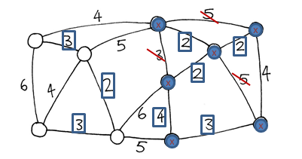
Figure 5: Check house connections

Now ask the students if all houses are connected. From figure 5, we can see that it’s possible to travel from any house with a filled circle to any other house that’s filled … but there’s no paved path to the four remaining houses.
Make sure the students understand this point. There are six houses that are connected. The other four houses are also connected to each other. So once we have a path between those two parts of the graph, we will be done.

Ask the students which path to choose. There are four ways to connect the two subgraphs, but we want to pick the lowest cost path. So we choose to pave the path of cost 4 at the top of the graph.

Discuss: what if there were two lowest-cost paths? [answer: We could choose either one of them. ]

A final solution is shown in figure 6. We have verified that we can get to every house. It is a minimal solution because for n houses (10 in this example), we need n-1 paths (i.e., 9). Adding extra paths would be redundant, because we only need one path to each house.
Figure 6: Solution to Muddy City

Activity 2 – Halloween Candy Worksheet
Now that the students are familiar with the concept of minimum spanning trees, pass out the Halloween Decorations Worksheet. Similar to Muddy City, have students create an MST with the Candy Worksheet.
Solution: We are just asking the students to circle the streets that they would decorate. The figure below also has the extra streets crossed out. It might be good to reinforce that you are minimizing the decorating costs, not creating a complete circuit (that would be a different type of algorithm).
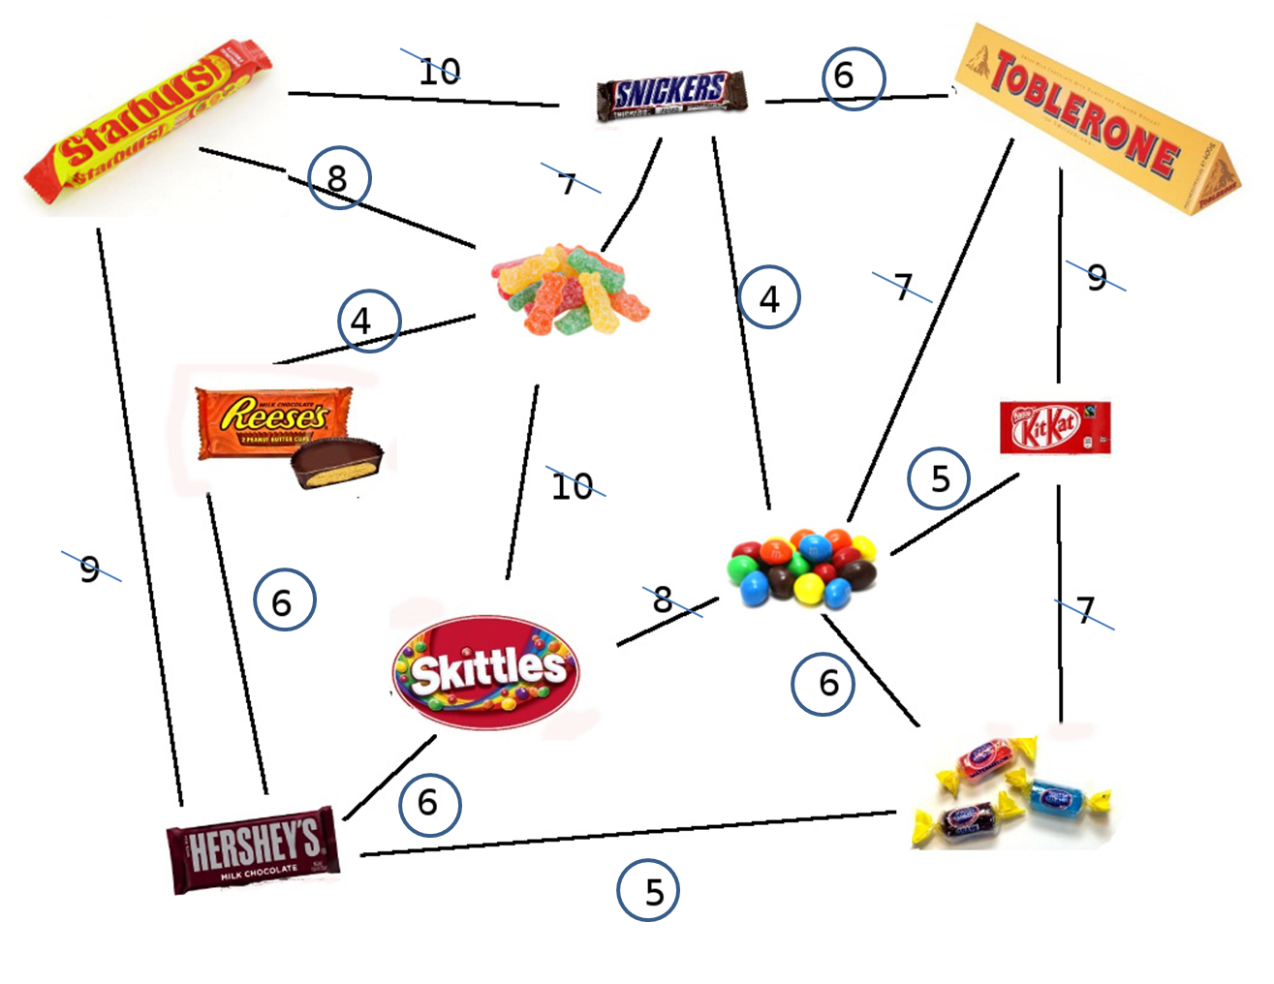

What’s It All About Discussion – Whole Class
Suppose you are designing how a utility such as electricity, gas, or water should be delivered to a new community. A network of wires or pipes is needed to connect all the houses to the utility company. Every house needs to be connected into the network at some point, but the route taken by the utility to get to the house doesn’t really matter, just so long as a route exists. There are a few other examples of situations like this below.
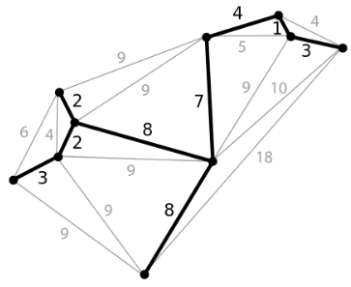
1. Power/Phone Lines: In the graph shown to the right, each node could represent a house in a neighborhood and each line represents the power line connection between each house. A city may wish to connect all houses with power lines at minimum cost. This would be an MST example. A cable company might use the same algorithm for connecting customers to the cable network.

1. Airline: In the graph shown to the right, each node could represent a city and each line represents the cost of fuel. The airline company might wish to connect all cities while minimizing fuel cost.

Minimal spanning trees help us solve a variety of network design problems. However, when deciding the best routes for people to travel, you do have to take into account how convenient the trip will be for the traveler as well as how much it will cost. No one wants to spend hours in an airplane taking the long way round just because it is cheaper for the airline. The muddy city algorithm may not be much use for these networks, because it simply minimizes the total length of the roads or flight paths.
In this lesson we have studied one efficient method for solving minimal spanning tree problems. This is called Kruskal’s algorithm after J.B. Kruskal, who published it in 1956.
Minimal spanning trees are also useful as one of the steps for solving other problems on graphs, such as the “travelling salesperson problem” which tries to find the shortest route that visits every point in the network. For many problems on graphs, including the “travelling salesperson problem”, computer scientists are yet to find fast enough methods that find the best possible solution.
There are also many other algorithms that can be applied to graphs, such as finding the shortest distance between two points, or the shortest route that visits all the points.

Activity 3 – DIY MST
As an exploratory activity (if time permits), split students up into groups of 2. Have each pair of students construct a connected graph using pennies and Q-tips. Then have 2 groups swap and try to find the minimum spanning tree of the graph. Have each group check each other’s MST.

